**SIMULATION TASK 3 RESULTS**

**Mean batch for RT and NonRT messages**

**RT messages observations for varying MIATnonRT**

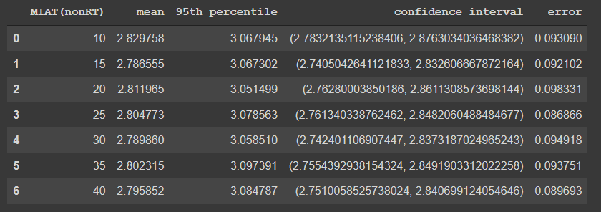

**NonRT messages observation for varying MIATnonRT**

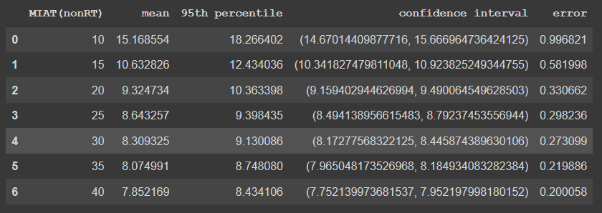

**Graphs:**

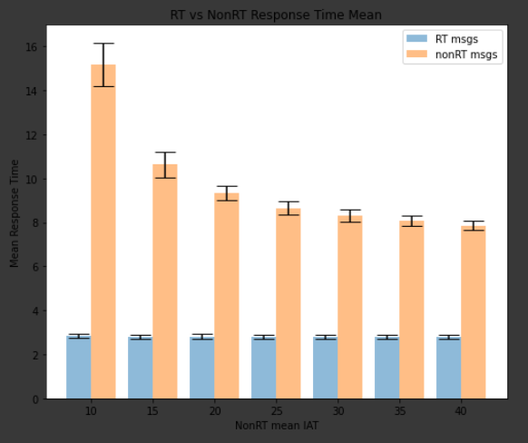

Shown above are two graphs plotting the mean response time for RT and nonRT messages. The first plots the response time as a function of MIATnonRT and the second plots it as a function of 1/MIATnonRT

Since RT messages have the higher priority they are serviced as soon as they arrive (if an RT message is not being processed already). Thus, the mean response time of the RT messages is nearly the same as the mean service time for RT messages. That is the same reason why the mean response time of RT messages remains almost the same across varying MIATnonRT.

On the other hand, the mean response time for nonRT messages is much greater than the mean service time for the nonRT messages. This is because, every time a RT message arrive, the nonRT message is pre-empted and put back into the nonRT queue. With the increase in the MIATnonRT the mean response time for nonRT messages decreases, along with the decrease in the width of confidence interval. The increase in MIATnonRT results in nonRT message queue to have a smaller number of messages to process at a given time, thus a given nonRT message doesn’t have to wait for other nonRT messages to get processed before itself. This results in a nonRT message being processed as soon as the server is idle (with the increase in MIATnonRT, less competition among nonRT messages to occupy the server). Smaller confidence interval indicates the mean value is closer to the 95th percentile and the distribution is less “fat” tailed. This decrease starts to become stable around MIAT=30 and will probably stabilize at this value even if the MIAT is increased beyond 40. The value of the mean response time at this stage is near the mean service time of nonRT messages as compared to lower MIATnonRT values. Increasing the MIAT beyond this point will not improve the response time by a significant amount, although the confidence interval might improve.

**Percentile batch for RT and nonRT messages**

**RT messages observation for varying MIATnonRT**

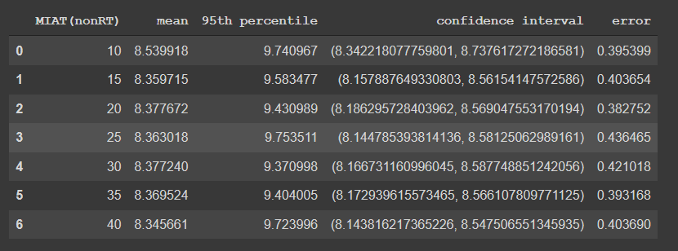

**nonRT messages observation for varying MIATnonRT**

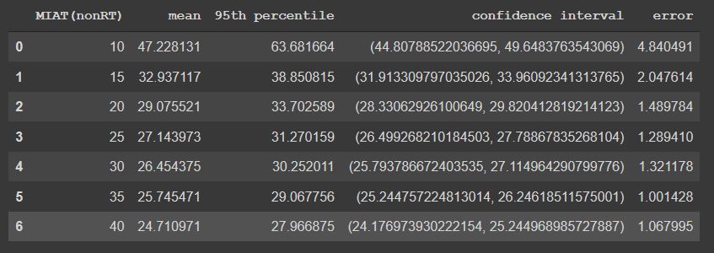

**Graphs:**

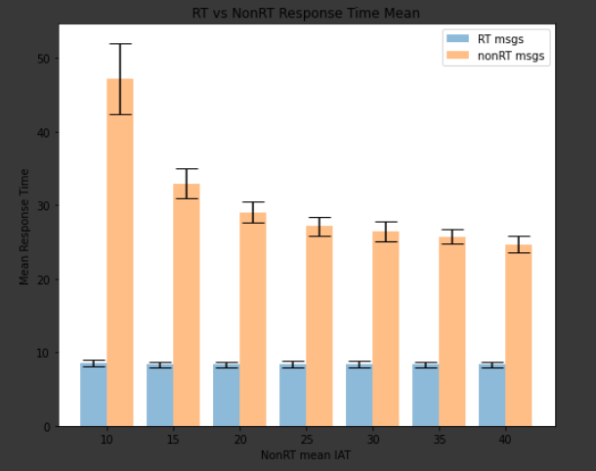

Shown above are two graphs plotting the mean response time for RT and nonRT messages. The first plots the response time as a function of MIATnonRT and the second plots it as a function of 1/MIATnonRT

The mean response time for both RT and nonRT messages is similar to the above graph which is expected. The RT message response time again remains almost constant with the varying MIATnonRT. The reason is that the RT messages have a higher priority and are processed as soon as possible. The mean response time value is higher than the mean service time because we are considering the 95th percentile values from a given batch and RT messages can get delayed if other RT messages are present in the queue ahead of a given message.

Mean response time for nonRT messages again decrease with the increase in MIATnonRT. The decrease is again because of the decrease in the number of messages present in the nonRT queue at a given time due to the increase in MIAT. The stable response time is much greater than the mean service time for nonRT messages because we considered the 95th percentile value from each batch. The mean response time again starts to stabilize around MIAT=30. The confidence interval again decreases as increase MIAT indicating that the mean value is getting closer to the 95th percentile (“slim” tail distribution)